./

GENESIS –Applied SDLC And Testing Mini-Project

Scientific Calculator

Team04

Scientific Calculator



|  |  |  |  |  |  |
| --- | --- | --- | --- | --- | --- |
| **Ver. Rel. No.** | **Release Date** | **Prepared. By** | **Reviewed By** | **To be Approved** | **Remarks/Revision Details** |
| 01 | 04-12-20 | 1. Karingula Sneha 2. Megha Annie George 3. Shashank Vodela |  | [Pagala Prithvi Sekhar](https://www.yammer.com/lnttsgroup.onmicrosoft.com/users/534664101888) |  |
|  |  |  |  |  |  |
|  |  |  |  |  |  |
|  |  |  |  |  |  |
|  |  |  |  |  |  |

**Details**

SCIENTIFIC CALCULATOR

Contents

SCIENTIFIC CALCULATOR 3

Contents 3

List of Figures 3

List of Tables 4

Activity 5 – Mini-Project Report 4

1 Requirements 4

1.1 State of the Art 4

1.1.1 Aging 4

1.1.2 Costing 4

1.2 What Why Where When How 4

1.3 My Product 4

1.3.1 High Level Requirements 5

1.3.2 Low Level Requirements 5

1.4 SWOT Analysis 5

2 Design 5

2.1 Behavioral Diagrams 5

2.1.1 High Level Diagram 5

2.1.2 Low Level Diagram 6

2.2 Structural Diagram 6

2.2.1 High Level Diagram 6

2.2.2 Low Level Diagram 6

3 Test Plan 6

3.1 High Level Test Plan 6

3.2 Low Level Test Plan 6

4 CI / CD 7

4.1 GitHub Dashboard 7

4.2 GitHub Link 8

Reference 8

# List of Figures

Figure 1 What Why Where When How 4

# List of Tables

Table 1 High Level Requirements 5

Table 2 Low Level Requirements 5

Table 3 SWOT Analysis 5

Table 4 High Level Test Plan 6

Table 5 Low Level Test Plan 6

# Activity 5 – Mini-Project Report

# Requirements

## State of the Art

A **scientific calculator** is a type of electronic calculator, usually but not always handheld, designed to calculate problems in science, engineering, and mathematics. They have completely replaced slide rules in traditional applications, and are widely used in both education and professional settings.

In certain context such as higher education, scientific calculators have been superseded by graphing calculators, which offer a superset of scientific calculator functionality along with the ability to graph input data and write and store programs for the device. There is also some overlap with the financial calculator market.

### Aging

* The first scientific calculator that included all of the basic ideas above was the programmable Hewlett-Packard HP-9100A,[[1]](https://en.wikipedia.org/wiki/Scientific_calculator#cite_note-1) released in 1968.
* The HP-35, introduced on February 1, 1972, was Hewlett-Packard's first pocket calculator and the world's first handheld scientific calculator.
* Texas Instruments (TI), after the production of several units with scientific notation, introduced a handheld scientific calculator on January 15, 1974, in the form of the SR-50.
* Casio, Canon and Sharp have also been major players, with Casio's fx series (beginning with the Casio fx-1 in 1972[[5]](https://en.wikipedia.org/wiki/Scientific_calculator#cite_note-5)) being a very common brand, used particularly in schools. Casio is also a major player in the graphing calculator market, and was the first company to produce one (Casio fx-7000G).

### Costing

Most of the online calculators are free of cost. Physical calculators cost vary from approximately 500 to 12000 Indian rupees.

## What Why Where When How

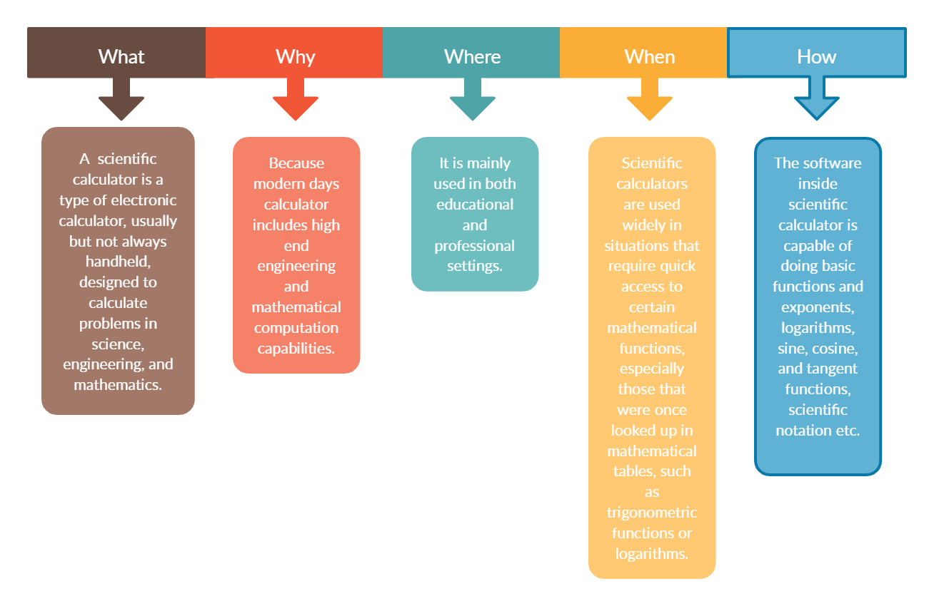

Figure 1 What Why Where When How

## My Product

### High Level Requirements

Table 1 High Level Requirements

|  |  |
| --- | --- |
| Requirement ID | Description |
| HLR10 | The program shall be able to compute basic trigonometric functions. |
| HLR20 | The program shall be able to compute hyperbolic functions. |
| HLR30 | The program shall be able to compute temperature conversions |

### Low Level Requirements

Table 2Low Level Requirements

|  |  |
| --- | --- |
| Requirement ID | Description |
| LLR11 | The program shall be able to compute the sine function. |
| LLR12 | The program shall be able to compute the cosine function. |
| LLR13 | The program shall be able to compute the tangent function. |
| LLR21 | The program shall be able to compute the hyperbolic sine function. |
| LLR22 | The program shall be able to compute the hyperbolic cosine. |
| LLR23 | The program shall be able to compute the hyperbolic tangent function. |
| LLR31 | The program shall be able to compute the temperature conversions |

## SWOT Analysis

Table 3 SWOT Analysis

|  |  |
| --- | --- |
| **Strength**   * Can solve complicated problems easily * It gives more accurate results | **Weakness**   * Can’t calculate complex values * Fixed Accuracy |
| **Opportunities**   * It can be integrated with smart devices | **Threats**   * Calculators integrated with smart devices poses some amount of security threads |

# Design

## Behavioral Diagrams

### High Level Diagram

### Low Level Diagram

## Structural Diagram

### High Level Diagram

### Low Level Diagram

# Test Plan

## High Level Test Plan

Table 4 High Level Test Plan

|  |  |  |  |  |  |
| --- | --- | --- | --- | --- | --- |
| Test Case ID | Test Scenario | Test Steps | Test Data | Expected Results | Actual Results |
| HLTP10 | Test whether the trigonometric functions are working correctly. | 1. Enter the inputsto test the sine, cosine and tangent functions. | 1. Sin90 2. Cos90 3. Tan90 | 1. 1 2. 0 3. 1 |  |
| HLTP20 | Test whether the hyperbolic functions are working correctly. | 1. Enter the inputs to test the sinh, cosh, tanh functions. | 1. 0 2. 0 3. 0 | 1. 0 2. 0 3. 0 |  |
| HLTP30 | Test whether the temperature conversion functions are working correctly | 1. Enter the input to test the celsius_fahrenheit,fahrenheit_kelvin,fahrenheit_celsius,celsius_kelvin,kelvin_celsius,fahrenheit_kelvin functions | 1.celsius_fahrenheit(100)  2.fahrenheit_kelvin(100)  3.fahrenheit_celsius(100)  4.celsius_kelvin(100)  5.kelvin_celsius(100)  6.fahrenheit_kelvin(100) | 1. 212 2. -279 3. 37.7 4. 373 5. -173 6. 310 |  |

## Low Level Test Plan

Table 5 Low Level Test Plan

|  |  |  |  |  |  |
| --- | --- | --- | --- | --- | --- |
| Test Case ID | Test Scenario | Test Steps | Test Data | Expected Results | Actual Results |
| LLTP11 | Test whether the sine function is working correctly. | 1. Enter the input for sine function. | 1. 90 2. 0 | 1. 1 2. 0 |  |
| LLTP12 | Test whether the cosine function is working correctly. | 1. Enter the input for cosine function. | 1. 0 2. 90 | 1. 1 2. 0 |  |
| LLTP13 | Test whether the tangent function is working correctly. | 1. Enter the input for tangent function. | 1. 90 2. 45 | 1. 1 2. 1 |  |
| LLTP21 | Test whether the hyperbolic sine function is working correctly. | 1. Enter the input for hyperbolic sine function. | 1. 0 2. 7 | 1. 0 2. 548.316123 |  |
| LLTP22 | Test whether the hyperbolic cosine function is working correctly. | 1. Enter the input for hyperbolic cosine function. | 1. 0 2. 1 | 1. 0 2. 1.54308063 |  |
| LLR23 | Test whether the hyperbolic tangent function is working correctly. | 1. Enter the input for hyperbolic tangent function. | 1. 0 2. 2 | 1. 0 2. 0.96402758 |  |

# CI / CD

## GitHub Dashboard

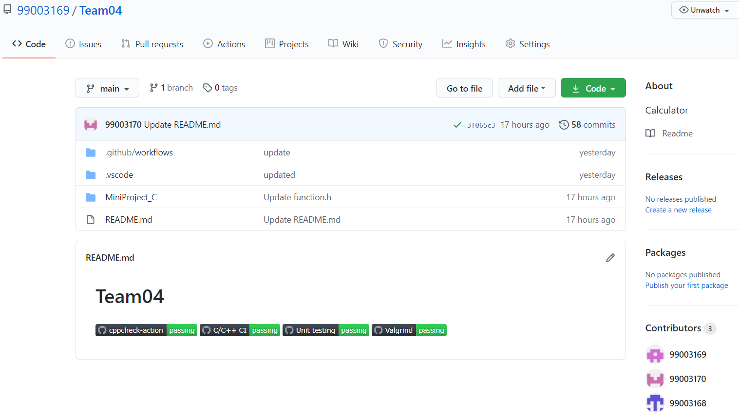

## GitHub Link

[99003169/Team04: Calculator (github.com)](https://github.com/99003169/Team04)

# Reference

* [Calculator - Wikipedia](https://en.wikipedia.org/wiki/Calculator)